Gamelan Music Question Sheet
From the island of Bali
- Name some traditional instruments from Indonesia.

- Music played in groups is called an _____________

- What does the word Gamelan mean?
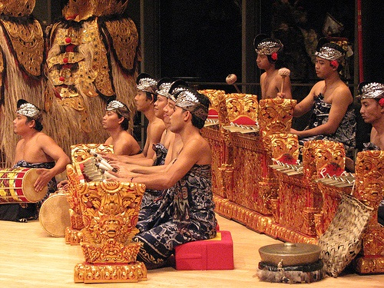

- What are metallophones?

- What is a rebab?

- What is a suiing?

- Name an Indonesian Drum

- How is this instrument played?

- What is the role of the drummer in the Gamelan?

- Name some other instruments you may find in a Gamelan orchestra.

- What is the simplest texture in Gamelan?

- The Sangsih is regarded as being the ______ ____ and the polos is regarded as being the ________ _______.

- Which part is the easiest and which part is the hardest?

- What types of beaters are used to play the sarons and gangsas?

- What types of beaters are used to play the gender?
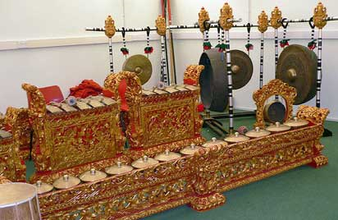
The most important traditional musical instruments in Indonesia are metallophones, gongs, cymbals and drums.
These are played in groups or ensembles, and the name given to such an ensemble is gamelan.
The word gamelan means to hit with a hammer, so it is not surprising that the gamelan is mainly made up of percussion instruments.
There are hundreds of different kinds of ensembles- gamelans come in all shapes and sizes.
They differ depending on the region - remember what an enormous country Indonesia is and how many different ethnic and religious groups there are — and the purpose for which the ensemble is playing.
The metallophones are sets of bronze bars, set in carved wooden frames and sometimes suspended over bamboo resonators.The gong instruments include single large gongs and smaller ones arranged in sets.
Different types of beaters are used to play Indonesian metallophones: sarons and gangsas are played with wooden, hammer-shaped beaters (I).
The gender is played with beaters with padded disc ends made of felt (2).
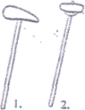

There are plenty of other instruments that are in common use. For example, in Bali, you might come across a group playing on xylophones in which the keys are made from bamboo tubes. This kind of ensemble is called gamelan joged. Another group of instruments is known as gamelan jegog, again made with bamboo keys, but some of these keys are 3 metres long - so big that the player actually sits on top of the instrument to play it. Sometimes instruments are used in processions. Or you might find a group of musicians playing the gengong, an instrument rather like a Jew's harp, as they accompany a dance-drama about a frog-prince.
Gamelan Music
From the island of Bali
The simplest sort of gamelan texture has just two parts that, while Independent, also interlock with each other.
This two-part texture is known as kotèkan.
Balinese musicians regard these two interlocking pats as being 'male' and 'female'.
They are known as sangsih (male part) and polos (female part). Rhythmically, the polos line is on the beat and simpler in style, whilst the sangsih off the beat and more complex in style.
Accompanying these percussion orchestras you will sometimes find a stringed instrument played with a bow called a rebab and a bamboo flute known as a suiing. Singers are also sometimes added to the orchestra. The instruments of a gamelan are often very ornate and may be painted in bright colours.
The Indonesian drum is called a kendang. It is double-headed. The player sits cross-legged on the ground and rests the drum horizontally across his lap. Sometimes the drum sits in a frame. The drummer has a very important role in the gamelan. He directs all the other players by using special signals on the drum, so they know when to speed up, slow down, change tune or finish a particular section of a piece.



